**Agriculture Science Ag Barn Facility Rules & Guidelines**

Texas Department of Agriculture Policy on Agriculture Education Pesticide Applications at Public School Districts 2-3

Authors 4

General Expectations 5

Livestock Premise Policy 5

Ag Barn and Livestock Pest Management 6

Facilities Usage 6

Project Management 7

Care of Project 7

Medication to Animals 7-8

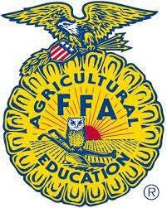

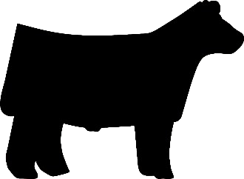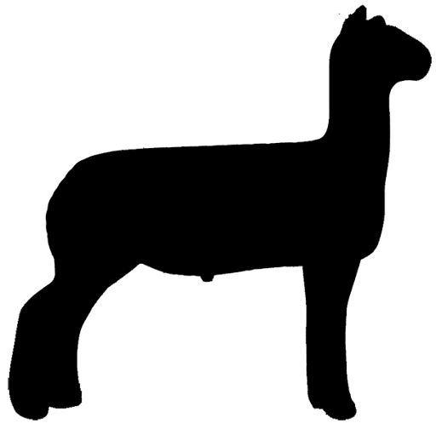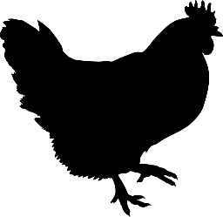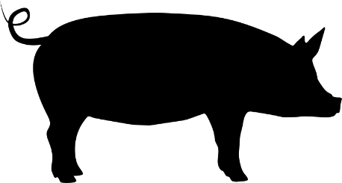

## Texas Department of Agriculture Policy on Agriculture Education Pesticide Applications at Public School Districts

Texas Department of Agriculture (TDA) has received requests for guidance regarding Integrated Pest Management (IPM) in Schools as it relates to pest control in ag barns, school gardens, and greenhouses located on public school premises. This policy document aims to clarify to all involved with ag barns, school gardens, and greenhouses pest control requirements under the Structural Pest Control Act and its related regulations.1 The goal of these requirements is to protect the health and welfare of students of public-school districts.

Under the Structural Pest Control Act, TDA establishes IPM standards used in schools and on school premises (“School IPM”).2 School IPM requires school districts to utilize the least toxic methods available to control pests. School IPM establishes categories of pesticides schools are allowed to apply, specifies re-entry intervals, mandates the posting of notices for indoor and outdoor applications of pesticides, requires approval prior to pesticide applications, and further requires maintaining records of the application of pesticides. Additionally, TDA has set standards for how school districts establish, implement, and maintain IPM programs to adhere to School IPM. School districts are required to adopt IPM programs that incorporate School IPM requirements and to designate IPM coordinators to implement their adopted IPM programs.

Any application of pesticides performed on school district properties are required to follow School IPM.3 . This would require all pesticide applications, including agricultural applications for school ag barns, gardens, or greenhouses to follow all established requirements of school districts’ IPM programs. As stated, a school district’s IPM Coordinator is responsible for implementing the IPM program. Anyone involved or planning to be involved in agricultural pest control activities on school property should consult with the IPM Coordinator to ensure that all pesticide activities are compliant with IPM program protocols. Likewise, an IPM Coordinator should have knowledge of anyone planning or involved in agricultural pest control activities on school property and should ensure these activities are compliant with IPM program protocols.

Notice posting for pesticide applications for ag education purposes on school property must be consistent with School IPM. A record of applications must be maintained regardless of the classification of the pesticide (e.g. general use pesticide, restricted use pesticide, etc.) consistent with the requirements of the licensee making the application.

1 Chapter 1951 of the Texas Occupations Code and Title 4, Chapter 7, Subchapter H, Division 7 of the Texas Administrative Code.

2 Tex. Occ. Code §1951.212.

3 Tex. Occ. Code §1951.212 (includes otherwise exempted agricultural pest control applications under Tex. Occ. Code §1951.054).

All pesticide application records must be maintained for two years. Ag education pesticide applications should be reflected in the school district’s IPM policy.

Ultimately, the goal of the IPM program is to ensure that our schools remain a healthy and safe environment for all who attend or work on these campuses.

Following IPM program protocols provides awareness of all pest control activities and can help prevent unapproved pesticide applications, which can have severe unintended consequences. If you have any questions, please contact the TDA at 1- 866-918-4481. More information regarding IPM in schools can be found at the following website: TexasAgriculture.gov/SPCS.

## Authors:

Don L. Renchie, Professor Extension Program Leader and Coordinator-Agricultural and Environmental Safety Unit. Pesticide Safety Education Program of Texas A&M AgriLife Extension Service

Avery Brooks, Student Worker I Meagan Domino, Student Worker I

## Support Staff:

Tina VanHorn, Business Coordinator II Shelby Smith, Administrative Associate II

## References:

Lewisville FFA; Lewisville ISD Agriculture Science Handbook and FFA Guide

Chapter 1951 of the Texas Occupations Code and Title 4, Chapter 7, Subchapter H, Division 7 of the Texas Administrative Code.

# Texas Independent School District Agriculture Science Ag Barn Facility Rules & Guidelines

The Texas Independent School District Ag Barn provides FFA members with a place to house their livestock projects that want to participate in a Supervised Agricultural Experience (SAE) program. These facilities are to only be used by Texas Independent School District actively enrolled members and/or paid members of the Texas Independent School District FFA Chapter who own or lease an animal project. Utilizing the Ag Barn facility is a privilege only for Texas Independent School District enrolled students.

This document outlines the expectations, rules, and regulations that must be adhered to, to create a positive experience in the program for all parties involved. To ensure compliance, Texas Independent School District employees including Agriculture Science Teacher(s), facility managers, maintenance workers, IPM coordinator(s), and administrators will monitor and manage the facility.

## General Expectations:

If you choose to keep your animals at the Texas Independent School District Ag Barn Facility or to use Texas Independent School District equipment (clippers, pens, etc.), please assist us in taking care of it. Persons responsible for intentional damage/vandalism to the property or equipment of the facility, district, or other students will be held financially responsible for repair of the damage and subject to disciplinary actions that may include removal from the barn.

## Livestock Premise Policy:

The goal of this policy is to ensure the safety and well-being of both the animals and students. It is important to understand the steps you can take to prevent disease transmission and how to properly notify people about a pesticide application.

## Disease Transmission Prevention:

* All animals housed in the school Ag Barns should be vaccinated and have regular health checks.
* Infected animals should be identified and quarantined.

## Supervision and Access Control

* To protect the safety and security of students and animal projects, all individuals seeking access to the Texas Independent School District Ag Barn Facility should consult with the Agriculture Science Teacher (AST) on proper access procedures.

## Ag Barn and Livestock Pest Management:

This policy aims to clarify to all involved with agricultural barns, school gardens, and greenhouses pest control requirements under the Structural Pest Control Act and its related regulations1. The goal of these requirements is to protect the health and welfare of students of public-school districts.

* Absolutely no chemicals, pesticides, sprays, etc. or other forms of pest removal products are allowed at the Ag Barn Facility, unless stated otherwise by the ASTs2.If there is a need to remove pests, ASTs need to report the issue to administration. All pesticide applications, including agricultural applications for school ag barns, gardens, or greenhouses should follow all established requirements of the school districts’ IPM program.
* Notice posting:
  + Signage should be presented when any form of pesticides is being used.
* Record Keeping:
  + Pesticide applications for ag education purposes on school property must be consistent with the School IPM program. The AST, working with students who use pesticides will secure and maintain a record of each application for **TWO** years from the date the application occurs. The AST will provide a copy of the record to the IPM Coordinator within an interval agreed upon between the AST and the IPM Coordinator. Records should include the product used (name & EPA Registration number), date of application, how much was applied, mixing rate or percent of active ingredient (if applicable), target pest and who made the application. Records may also be recorded using the Texas Department of Agriculture’s Pesticide Applicator Record Q527. The items identified previously must be completed on the Q527 if utilized. Some pesticides require approvals to be completed (i.e. Yellow or Red category). The AST should consult with the IPM Coordinator to determine any applicable approvals are necessary.

## Facilities Usage:

The Ag Barn facility is to be used only for feeding and caring for the livestock projects.

* NO loitering at the facility.
* NO pets are allowed on the Ag Barn Facility grounds for any reason, unless otherwise stated by the ASTs. This is for the safety of pets, species projects, and people at the Ag Barn facility.
* All gates should remain shut and locked at all times.
* NO chemicals, pesticides, sprays, or other forms of pest removal products are allowed at the Ag Barn Facility unless they are ectoparasiticides and for premises pest management purposes. These pesticides must be used in accordance with product labels, Safety Data Sheets (SDS), and under the supervision of the AST in compliance with the Texas IPM in Schools regulations.
* NO additions, subtractions, modifications, or construction relating to electricity, carpentry, plumbing, or location may be made.
* All rules, care of project and feeding procedures apply to holidays, weekends, and any other district closures.

1Chapter 1951 of the Texas Occupations Code and Title 4, Chapter 7, Subchapter H, Division 7 of the Texas Administrative Code.

2Tex. Occ. Code §1951.212.

## Project Management/Care of Project:

The Supervised Agricultural Experience (SAE) project is the student’s responsibility. All project management decisions will be made by the student/parent in cooperation with the supervising species Agriculture Science Teacher(s). The AST will closely monitor all show rules. Ethical treatment of projects is expected at all times. The care of the project is the sole responsibility of the student. It is prohibited to go into a pen, feed, or handle a project that does not belong to you, unless prior permission is granted by the owner of the project. Any concerns regarding the care of a project at the barn need to be addressed with the AST.

* Pens/Stalls:
  + Wet soil or shavings and feces are to be removed daily.
* Aisle:
  + The aisles are to remain clean and free of trash, shavings, forage, etc. This is the responsibility of all students. Tack is to be kept in designated areas and stored neatly.
* Feeding Procedures:
  + Projects are to be fed twice daily on a twelve-hour schedule, or as advised by species Ag Science Teacher(s). Be consistent. It is recommended that feeding should be done before 10:00 a.m. and prior to 10:00 p.m. Animals are creatures of habit. Consistency is necessary even on the weekends, holidays, and any other district closures. Regardless of the weather conditions, your animal(s) need to be fed and given fresh water. This includes rain, snow, ice, and cold/hot weather.
* Water:
  + Fresh, clean water should be supplied daily to your project.

## Medication to Animals

Teachers, students, and parents will follow all major show rules regarding feed and drug residue restrictions. The Ag Science Teacher(s) will not knowingly recommend any illegal drug or substance. The rules regarding substances change regularly, so do not depend upon what you could or could not do when you were showing before the current situation. All medications, substances, or other treatment must be approved by Ag Science Teacher(s) before being administered.

* NO medication including but not limited to off-label or extra-label vaccines, medications, sprays, feed additives, over the counter medications, and/or vaccinations or other substances will be given internally or externally to any livestock project without approval of the species Ag Science Teacher(s). All established withdrawal times for any administered product must be strictly followed. The Ag Science Teacher(s) will notify students and/or parents if medication must be administered to any animal.
* The Ag Science Teacher(s) will seek a veterinarian's assistance if they have any questions about medication.
* In the event an animal tests positive on a drug test before, during or after a major event, the student and/or parent must inform the species Ag Science Teacher(s) immediately.
* All animals shown under the Texas Independent School District FFA Chapter must follow these guidelines regardless of if owned, leased, or consigned.

# ACKNOWLEDGMENT OF THE TEXAS INDEPENDENT SCHOOL DISTRICT AGRICULTURE SCIENCE AG BARN FACILITY RULES & GUIDELINES

My student and I accept responsibility for assessing, reading, and following the guidelines in the Agriculture Science Ag Barn Facility Rules and Guidelines. I understand that the Agriculture Science Ag Barn Facility Rules and Guidelines contain information that my student and I may need during the school year. All students will be held accountable for their behavior in this document. This policy serves as a contract for the students of the Texas Independent School District FFA Chapter for the Ag Barn Facility.

Student Signature: Date: Parent Signature: Date: